**Reducing Risk & Maximizing Potential Reward In Swing Setups**

Frame the trades from the monthly and weekly, so frame the sell from these timeframes but frame the objectives from these timeframes as well

He shows the orderblocks now, because showing every PD array would make the videos insanely long

We sell from a monthly premium array into the first monthly discount array from the PD array matrix Keep risk small

If you have other things to do, 4h might be ideal for you

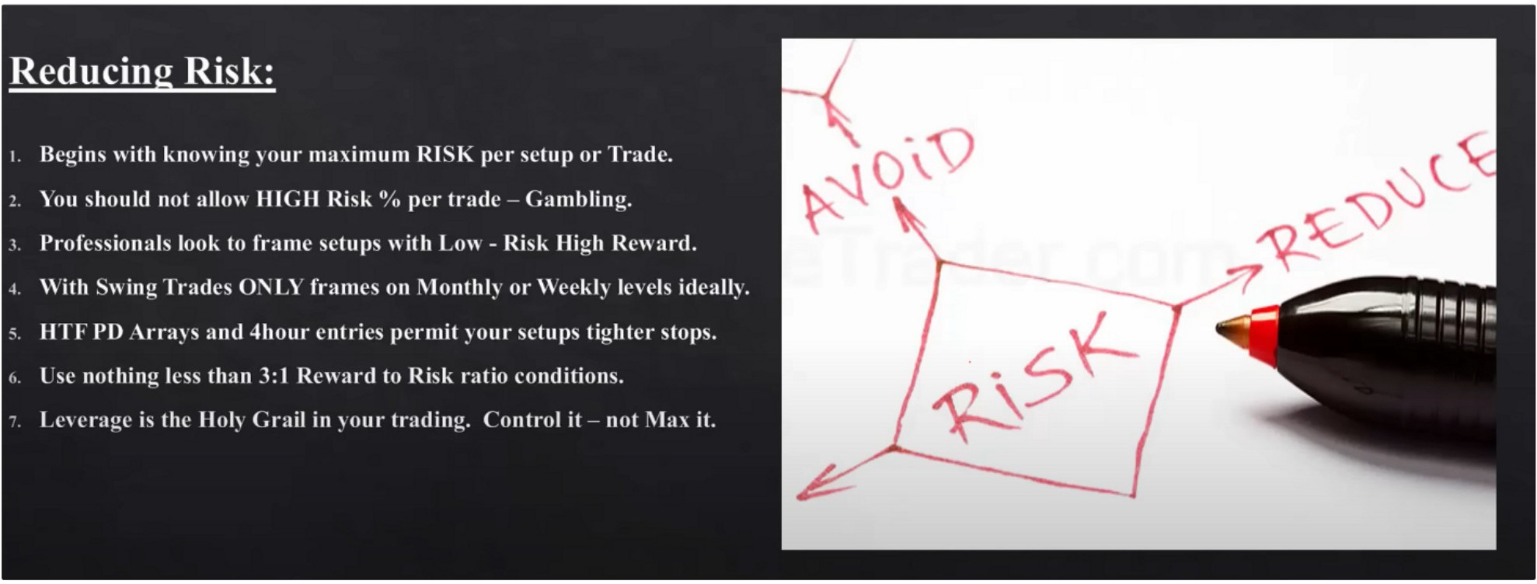The stop orders and limit orders are going to be used in swing trading as well, only then on th 4h not on the daily

You dont need a lot of leverage, you dont need 1:50 to get wealthy



If you think you have to trade a lot to do well in this business youre very wrong.

Youre presented a lot of time to prepare for these trades, even when you have another business on the side.

Once you get to the 2 million funds mark, you should consider getting into prime brokers, prime brokers will not allow you to leverage.

1:10 RR is easy to find in swing trading

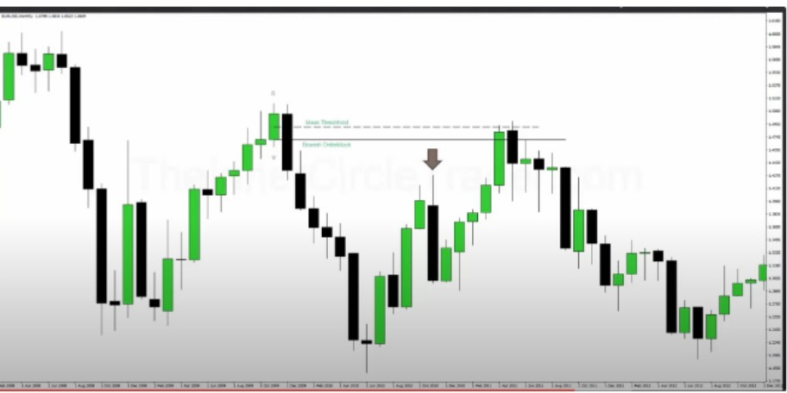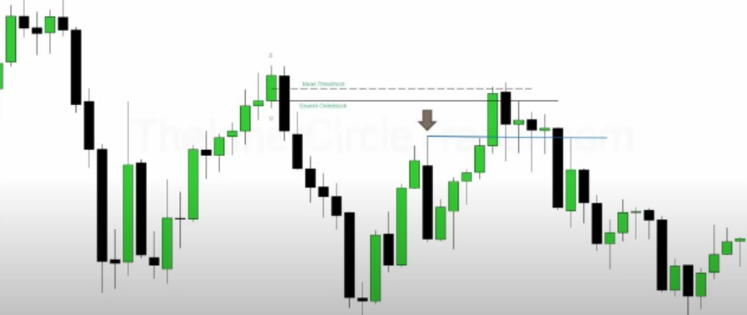

Thats the first discount PD array, an old high. The first target

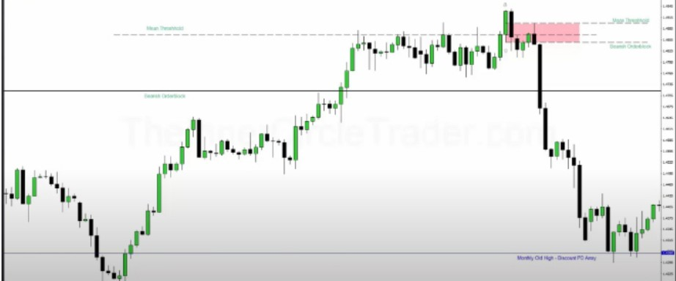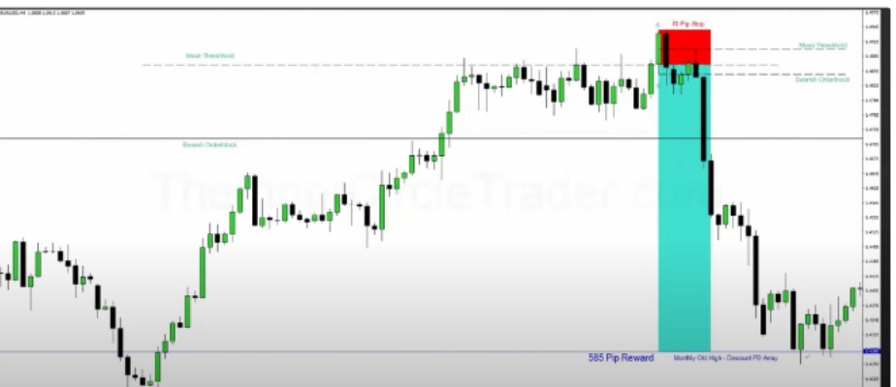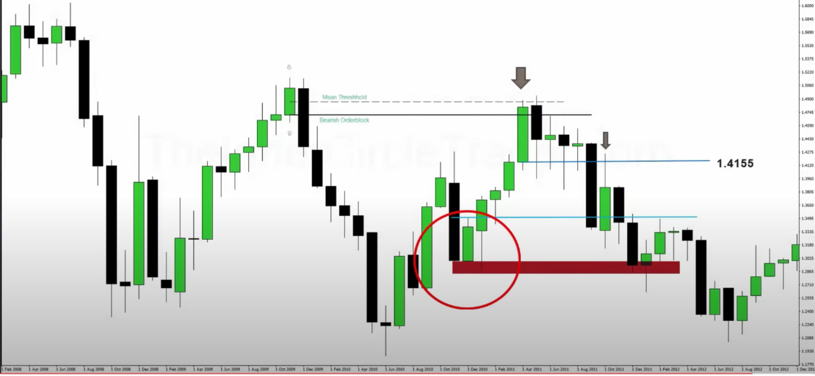

Homework objective: look for shorts at 1.4155 and target the mean threshold and the low, use the position trading entry technique to get in

After youve done this go and find 5 more examples, atleast 2 buys and 2 sells. Minimum 1:5 R

Arjo I Twitter, lnstagram I Linktree

Linktree. Make your link do more.

, https://t.co/HhmmTN1fUI

JavaScript is not available.

"I# https://twitter.com/arjoio